**1 - Reverse flow capability of transformers**

Is this a fixed property of a transformers or a result of a load flow calculation for a particular scenario? In general, transformers are able to support both load flow directions. Is this a market or protection based restriction?

Really good question.

Simple answer: It is intended to reflect physical transformer capabilities, not wider system capabilities or constraints.

Nuanced answer: However, reverse flow limits, like transformer limits in LTDS, also reflect a DNO choice about how the transformer is allowed to be operated (and could conceivably consider limitations of other equipment (like circuit switchers or breakers) or auxiliary equipment along the ‘transformer circuit’ between high and low voltage busses).

For background, the requirement for a reverse flow limitation came from Table 2 – Transformer Data of the 2011 version of the LTDS Form of Statement,

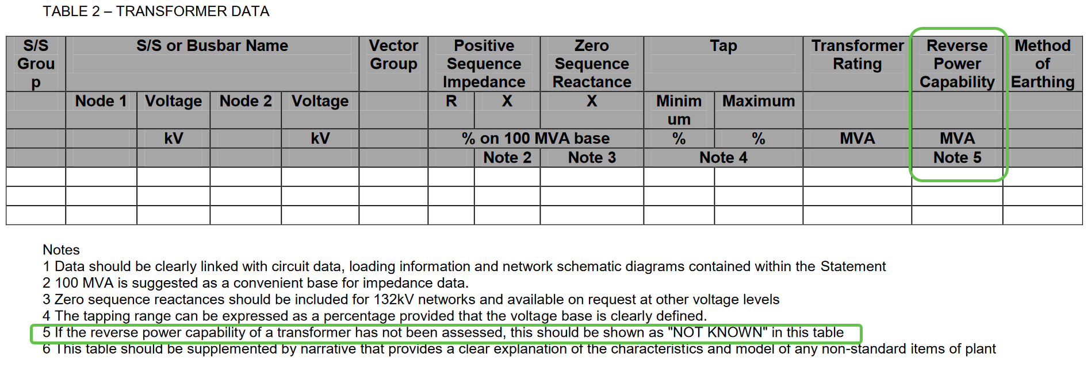

Here’s a sample of the LTDS Table 2s published by various DNOs in 2022 under the 2011 FoS requirements:

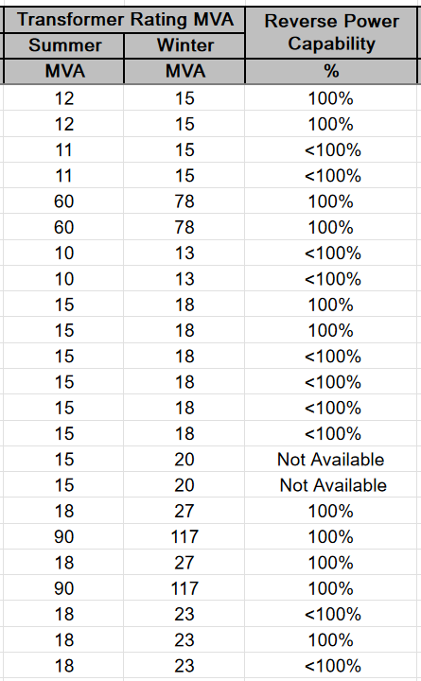 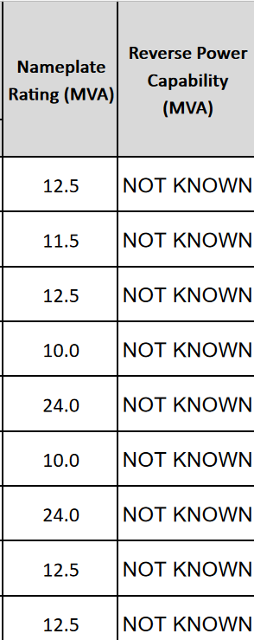 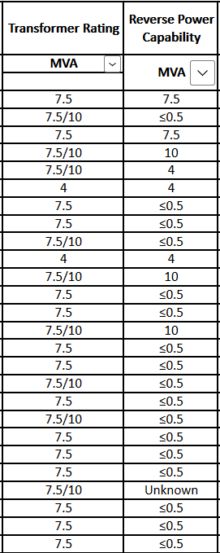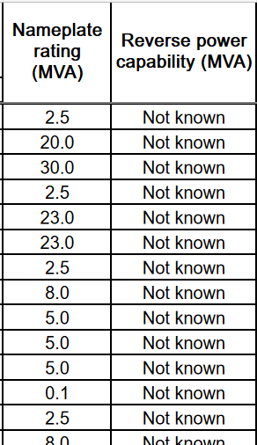

Some DNOs filled out the Table based strictly on nameplate (though the choice of which of the manufacturer MVA ratings was used (e.g., ‘no fan/no pump’, ‘fan/no pump’, or ‘fan/pump’) varied) other DNOs adjusted the ratings values based on ambient temperature considerations. Some DNOs supplied some information related to reverse power capability for nearly every transformer, others universally said the information was not known. Conversations with the DNOs in LTDS Working Group meetings reflected the same divergence of interpretation.

Given this context, we decided to implement the expression of reverse flow limits in a fashion parallel to that used for ‘normal’ transformer MVA limits, by using the CIM OperationalLimit collection of classes:



The definition of the meaning of the ApparentPowerLimit.normalValue for the normal flow direction would be something like:

*The apparent power operating limit of the transformer circuit for power flowing into the transformer high voltage winding which is used by the DNO for its studies related to a time of year falling between the validFrom and validTo dates.*

And the definition for reverse flow direction would be something like:

*The apparent power operating limit of the transformer circuit for power flowing out of the transformer high voltage winding which is used by the DNO for its studies related to a time of year falling between the validFrom and validTo dates.*

The main intent of this data structure was to allow a DNO to share the limit value(s) it would typically use in its own studies of various conditions at various times of year. The assumption being that the sharing of those limits would enable folks submitting connection applications to have the best understanding of how a DNO might evaluate the application.

It’s probably important to point out that the population of the data structure could be as simple as putting a transformer nameplate rating value in ApparentPowerLimit.normalValue and not considering any other limiting ‘transformer circuit’ elements.

Note also that the ApparentPowerLimit object is not required for transformers whose reverse flow capability is declared unknown (via the gb:PowerTransformer.reverseFlowCapability attribute).

A couple other notes related to the processes of model creation and use relative to reverse flow data:

* cim:OperationalLimitSet objects are associated with cim:Terminals, which allows their associated OperationalLimit subtype objects to be easily used as the violation limits for power flow solutions, since cim:SvPowerFlow objects (which represent power flow solution flows) are also associated to cim:Terminals.
* Normal operational limit values are supplied in the Equipment (EQ) profile in the .normalValue attribute of OperationalLimit subtype objects. As the LTDS Grid Modelling Annex 1: Grid Modelling Guidelines document notes, in the Steady State Hypothesis (SSH) profile, “A cim:OperationalLimit subtype object has its cim:OperationalLimit.value attribute populated only if it is associated with the cim:OperationalLimitSet whose period of validity includes the date being represented by the Steady State Hypothesis Full Model. “ This means that the software creating a “solved case” for export needs to know the date being represented and to appropriately populate both the md:Model.scenarioTime in the header of the exchange and the correct OperationalLimit subtype object (the one associated with a cim:OperationalLimitSet covering the date represented). If a given transformer is described with cim:PowerTransformer.reverseFlowCapability=differentFromNormal, the appropriate cim:OperationalLimit subtype object for both normal direction and reverse direction need to be populated.
* A system receiving a “solved case” should expect to find and interpret the following data in a “solved case” in the following way

|  |  |  |  |  |
| --- | --- | --- | --- | --- |
| cim:PowerTransformer  .reverseFlowCapability (in EQ) | which winding | cim:OperationalLimitSet object (in EQ) which connects power transformer cim:Terminal object to appropriate cim:ApparentPowerLimit object | Number of cim:ApparentPowerLimit objects associated with the cim:OperationalLimitSet object  Which cim:OperationalLimitType object each cim:ApparentPowerLimit object is associated with | Use of cim:ApparentPowerLimit.value attribute |
| =sameAsNormal | High-voltage winding | cim:OperationalLimitSet within whose .validFrom and .validTo dates the cim:Model.scenarioDate falls | One cim:ApparentPowerLimit object which is associated with a cim:OperationalLimitType object with .transformerReverseFlow=false | As violation limit for power flowing either into or out of the transformer’s high voltage winding |
| Lower-voltage winding of 2-winding transformer | none | none | none |
| Lower-voltage winding of 3-winding transformer | cim:OperationalLimitSet within whose .validFrom and .validTo dates the cim:Model.scenarioDate falls | One cim:ApparentPowerLimit object associated with a cim:OperationalLimitType object with .transformerReverseFlow=false | As violation limit for power flowing either into or out of the transformer’s lower voltage winding |
| =differentFromNormal | High-voltage winding | cim:OperationalLimitSet within whose .validFrom and .validTo dates the cim:Model.scenarioDate falls | One cim:ApparentPowerLimit object which is associated with a cim:OperationalLimitType object with .transformerReverseFlow=false | As violation limit for power flowing into the transformer’s high voltage winding |
| One cim:ApparentPowerLimit object which is associated with a cim:OperationalLimitType object with .transformerReverseFlow=true | As violation limit for power flowing out of the transformer’s high voltage winding |
| Lower-voltage winding of 2-winding transformer | none | none | none |
| Lower-voltage winding of 3-winding transformer | cim:OperationalLimitSet within whose .validFrom and .validTo dates the cim:Model.scenarioDate falls | One cim:ApparentPowerLimit object associated with a cim:OperationalLimitType object with .transformerReverseFlow=false | As violation limit for power flowing either into or out of the transformer’s lower voltage winding |
| =notYetDetermined | High-voltage winding | cim:OperationalLimitSet within whose .validFrom and .validTo dates the cim:Model.scenarioDate falls | One cim:ApparentPowerLimit object which is associated with a cim:OperationalLimitType object with .transformerReverseFlow=false | As violation limit for power flowing either into or out of the transformer’s high voltage winding |
| Lower-voltage winding of 2-winding transformer | none | none | none |
| Lower-voltage winding of 3-winding transformer | cim:OperationalLimitSet within whose .validFrom and .validTo dates the cim:Model.scenarioDate falls | One cim:ApparentPowerLimit object associated with a cim:OperationalLimitType object with .transformerReverseFlow=false | As violation limit for power flowing either into or out of the transformer’s lower voltage winding |

The following is also noted in the LTDS Grid Modelling Annex 1: Grid Modelling Guidelines document, “The value of the cim:ApparentPowerLimit.value attribute must always be positive and solution flows are considered to be in alarm or violation when they exceed the specified limit. For transformers where the reverse flow limit is different from the normal flow limit, network analysis software is responsible for determining direction of flow through a transformer and using the appropriate cim:ApparentPowerLimit.

**2 - Operational limits for switches**

If a switch is the limiting component in a branch, operational limits based on dates shall be provided. Is acceptable, if the bay provides the limit?

Probably need more clarification on your question. In CIM, a Bay is a container (a cim:EquipmentContainer subtype) and as such has no cim:Terminals to which a cim:OperationalLimitSet could be associated.

The new LTDS (based on the philosophies of the 2011 LTDS) stipulates that operational limits are required to be supplied at two places:

* One or more seasonal* ApparentPower operational limits are required at the cim:Terminals of Power Transformers (as reflected in item 1 above, there are fairly complicated rules about what limits should appear at what terminals for various types of transformers)
* One or more seasonal* Current operational limits are required at one cim:Terminal of every cim:ACLineSegment. Additionally Current operational limits can be associated with the cim:Terminals of devices (cim:ConductingEquipment subtypes) if the device is a most limiting series element on a circuit.

* Note that the ‘seasonal’ referred to above might just be one ‘season’ – in other words the same limit applies throughout the calendar year. (This is accomplished by setting .validFrom and .validTo to the same month and day)

**3 - Overlapping of date in OperationalLimitSet**

In the screenshots provided in the LTDS specification the TO date of a former period and the FROM date of the next period are the same. It’s unclear to which period the particular day belongs to. Please provide clarification on this.

Good catch. We need to add some description to the OperationalLimitSet.validFrom and .validTo attributes in the UML (and likely in the LTDS Grid Modelling Annex 1: Grid Modelling Guidelines document).

The intent was to follow the CIM convention where the beginning of a time period starts at the specified start time and end of a time period is defined as ‘up to, but not including’ the specified end time. The DateTimeInterval compound documents this concept, but it’s not used by OperationalLimitSet, so we need to restate the concept in our OperationalLimitSet extension.

**4 - Equivalent branch elements for network reduction**

The reduction of a network is a common approach to avoid providing confidential details of a network to external stakeholders. In CGMES, two classes are available; the *EquivalentInjection* for single port devices or generation or a network impedance in general and the *EquivalentBranch* for two port devices. The *EquivalentBranch* is important to anonymize the network between substations. This class is not used in LTDS. Is it expected that other classes shall be used for this use case? If not, it would be useful to add this to the LTDS specification.

The use of EquivalentInjection and EquivalentBranch seems like a reasonable approach for obfuscating details of a DNO’s network if it needs to be done for commercial or security reasons. EquivalentInjection is already in the LTDS EQ, SC and SSH profiles and its use in modelling networks external to the DNO network was described in the LTDS Grid Modelling Annex 1: Grid Modelling Guidelines document. It would be good to get an example of a situation where EquivalentBranch would be useful. Then we could add a little section to the LTDS Grid Modelling Annex 1: Grid Modelling Guidelines to cover internal anonymization.

**5 - Unbalanced short-circuit calculation**

Is it intended to provide information to run unbalanced short-circuit calculations with LTDS data? Actually the data is a little bit inconsistent (earthing method: yes, but earthing impedance: no)

Short answer: No.

Longer answer: Complete modelling of the input data required for short circuit analysis was discussed several times in the LTDS Working Group meetings. The decision that was taken, however, was to require only the short circuit data (both input and output) already required by the 2011 LTDS. Consensus was that it was going to be sufficiently challenging to successfully exchange power flow inputs and outputs and that short circuit data should be left to a future LTDS initiative. This decision was aided by the fact that there were questions (on the part of power system engineers from DNOs accustomed to running short circuit studies) about the completeness of the Short Circuit input data modelling in the CIM. (We all recognised the complete lack of short circuit result data modelling in CIM and knew that a bit of it needed to be developed just to support the data required by the 2011 LTDS. Figured accomplishing that data model extension was enough of a stretch for a first round implementation.)